Jenkins lab:

This lab, we will be integrating Jenkins with Github to so that Jenkins is notified when new code is pushed to the repository. When Jenkins is notified, it will checkout the code and test it within Docker containers to isolate the test environment from the Jenkins host machine

Add the Jenkins User to the Docker group

After following the prerequisites, both Jenkins and Docker are installed on the server. However by default, the Linux user responsible for running the Jenkins process cannot access Docker.

To fix this, we need to add the Jenkins user to the docker group using usermod command

root@master:~# sudo usermod -aG docker jenkins

root@master:~# grep docker /etc/group

docker:x:999:jenkins

root@master:~# systemctl restart jenkins

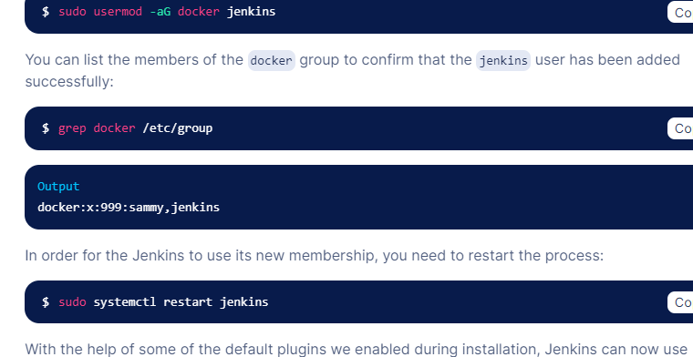

Create a personal access token in Github

In order for Jenkins to watch your github projects, you will need to create a Personal Access Token in our github account.

1. Begin by visiting Github and signing into your account if you haven’t already done. Afterwards, click on the user icon in the upper-right hand corner and select the Settings from drop down menu:

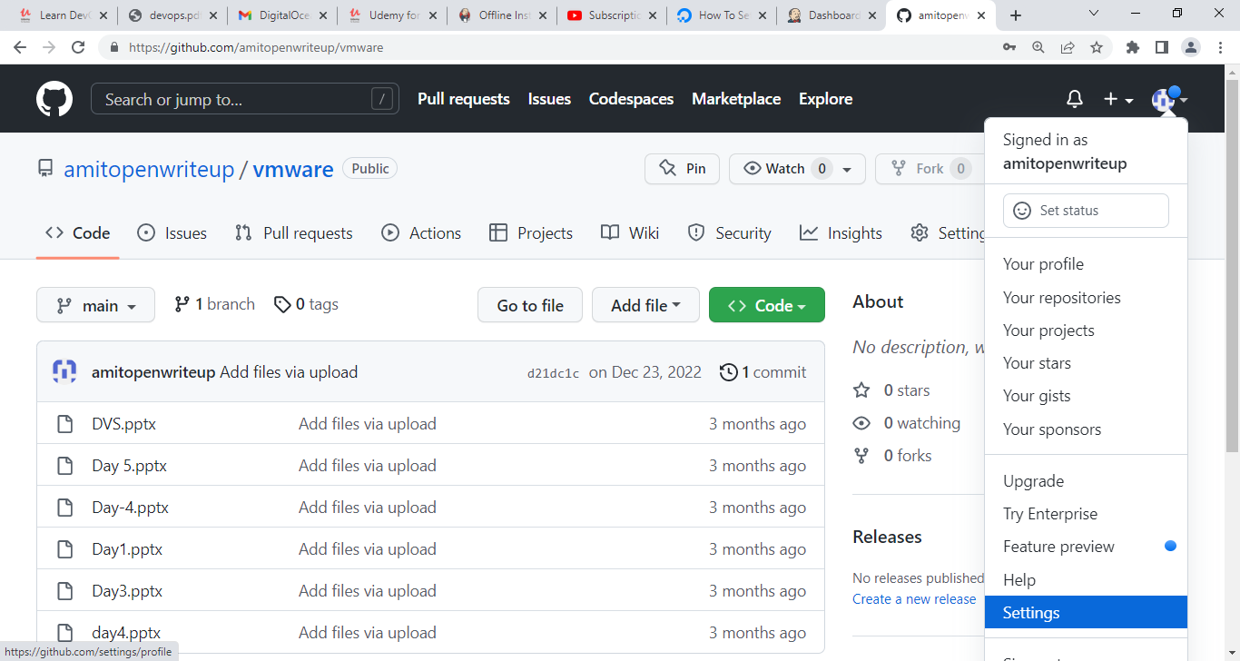

1. On the page follows, locate the Developer settings section of the left-hand menu and click Personal access Tokens

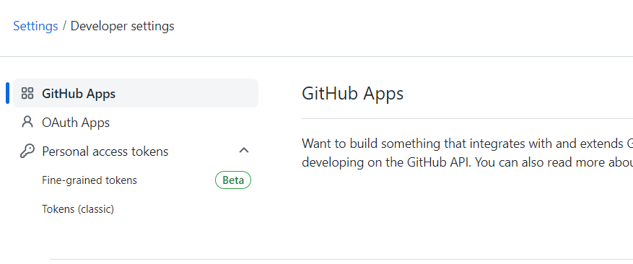

Click on **Generate new token** button on the next page:

GitHub generate new token button

You will be taken to a page where you can define the scope for your new token.

In the **Token description** box, add a description that will allow you to recognize it later:

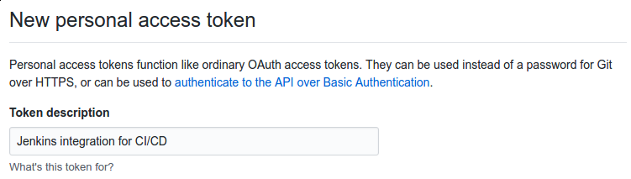

In the **Select scopes** section, check the **repo:status**, **repo:public_repo** and **admin:org_hook** boxes. These will allow Jenkins to update commit statuses and to create webhooks for the project. If you are using a private repository, you will need to select the general **repo** permission instead of the repo subitems:

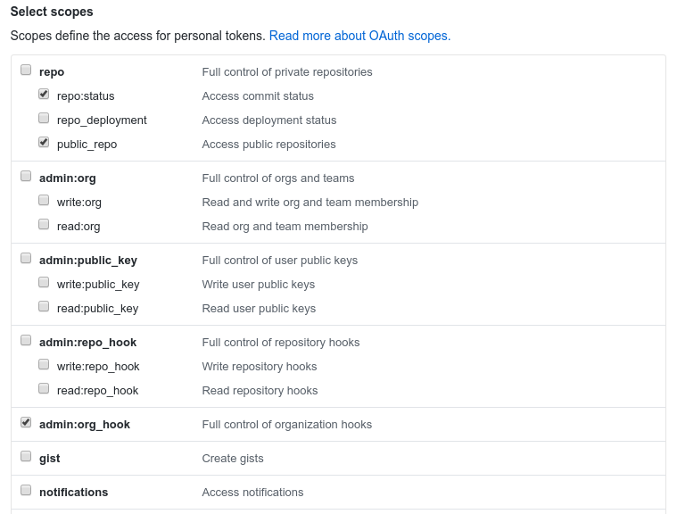

When you are finished, click **Generate token** at the bottom.

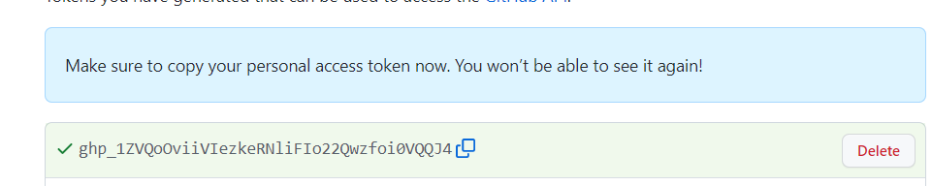

1. Add the github personal access token to Jenkins

Now we have a token, we need to add it to our Jenkins server so it can automatically setup webhooks. Login into your Jenkins web interface using administrative account you configured during installation

From the main dashboard, click Credentials in the left hand menu:

